

SALESFORCE
FULL STACK DEVELOPER

APPRENTICESHIP REPORT
2019 – 2020

ARSENE LAPOSTOLET
L3 – APP LSI

COMPANY: EDIFIXIO
APPRENTICESHIP ACADEMIC SUPERVISOR: EDOUARD PAUMIER
APPRENTICESHIP COMPANY SUPERVISOR: ACHRAF DHOUIB
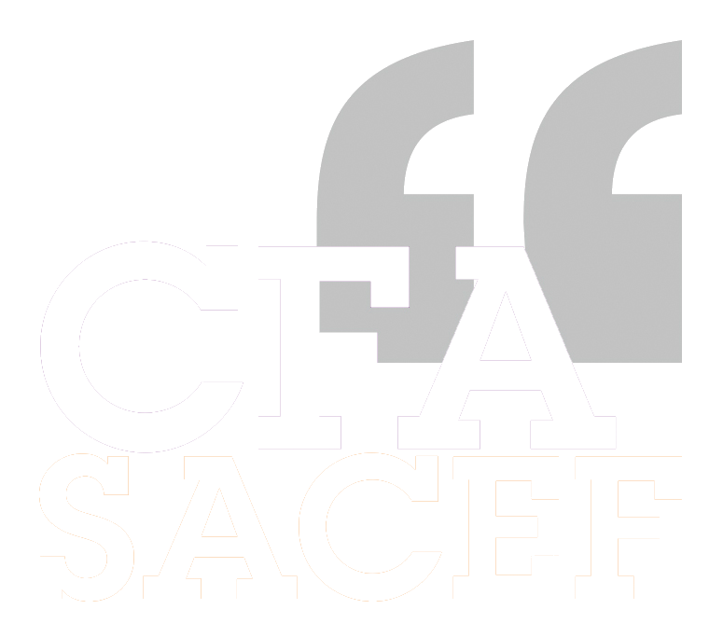

Abstract
In the context of my apprenticeship, I stayed at Edifixio after my internship as a full stack developer. I am a collaborator of the ESIA team working on internal projects.
This mission allowed me to get more experience at developing applications on the Salesforce Platform using the following technologies: SOQL for the database, APEX language in the back end and Javascript in the front end, with the Lightning Web Component framework. I used IntelliJ IDEA as an Integrated Development Environment (IDE).
My first mission was therefore to finish the development of Timesheet Report, a working time reporting application. Then, I was assigned to the development of a new application, Staffing, a resource allocation planning application. I was also assigned on another developer’s project, TRH, a leave management application, to help him finalize its development and deliver it.

Thanks
I would like to thank all the persons who assisted and supported me throughout this first year of apprenticeship at Edifixio.
First, I thank all the teachers who accompanied me during my coursework this year at EFREI. In particular, Edouard Paumier whose teachings helped me step up my understanding of code quality and also for his caring and helpful presence as my apprenticeship academic supervisor.
I would also like to thank the people from Edifixio who followed me throughout this year of apprenticeship, Achraf Dhouib and Matthieu Cuenin for their guidance and advice, but also the people of my team who made me feel comfortable as an Edifixian.
I would also like to thank the community of developers on the web who, thanks to their ability to help each other, especially through platforms such as Stackoverflow, allow us to solve our problems.

Summary

Abstract 2
Thanks 3
Summary 4
Introduction 6
I. Edifixio 7
1. Main activity 8
2. History 8
3. Edifixio Business Partners 9
Salesforce 9
IBM 9
AWS 9
Azure 9
MuleSoft 9
II. ESIA Business Unit and Salesforce team 10
1. ESIA Business unit 10
2. Salesforce team 11
A growing team 11
Diverse skillset 11
III. Salesforce Full Stack Developer 12
1. Full Stack Developer 12
Design 12
Develop 13
Full Stack 13
2. Develop on Salesforce 14
What is Salesforce? 14
Salesforce Applications Development 15
Work Organization 18
Salesforce Full Stack Developer Toolbox 19
III. Achievements 20
Timesheet Report Project 20
TRH Project 23
Staffing Project 24
IV. Achievements statement 26
1. Challenges encountered 26
2. Acquired abilities 26
3. Evolution perspectives 27
Conclusion 28
Table of figures 29

Introduction
For a long time, my education objective was to become a software engineer. To fulfill this goal, and desiring to learn specific and practical abilities, I took a technical degree in computer science. This degree allowed me to apply for an engineering school. I choose EFREI for its very technical program, and the possibility to specialize in software engineering from the outset. I also choose to be an apprentice because I wanted to peer my educational knowledge with real work experience. I knew Edifixio from my technical degree internship, and the company offered me to stay for my apprenticeship.
Therefore, this year of apprenticeship is the continuation of my career at Edifixio and as a full stack developer.
During this year, I upgraded and professionalized my working methods by applying engineering techniques. Thanks to the challenges I faced, to my teachers, and my colleagues, I acquired a lot of new abilities and knowledge. I leveraged all these assets to produce applications featuring better UX/UI, better code quality, better application design and which are more maintainable. These qualities have been and ever will be my main goals as a software engineer.
I also learnt how to collaborate with other developers and non-technical personnel in the professional context, and to organize teamwork in order to get the best of joint effort.
This file sums up this year, first introducing Edifixio and my business unit. I will then explain my role and my work, describe the tools I used. Furthermore, I will go through the projects I have contributed to and finally, bring forth a statement of my achievements.

I. Edifixio
Edifixio is a software firm with about 300 collaborators in France with three offices in Levallois and Grenoble, but Edifixio also has a worldwide dimension with teams in the USA, Tunisia, and India. The software consulting & engineering industry is a constantly growing sector in the French economy. Edifixio is a simplified stock company with a capital of 22 000€. It was founded in 2000. Edifixio’s core business is to design, build and operate connected and cloud applications. The head office of the company is at 123 Rue Jules Guesdes, Levallois-Perret.
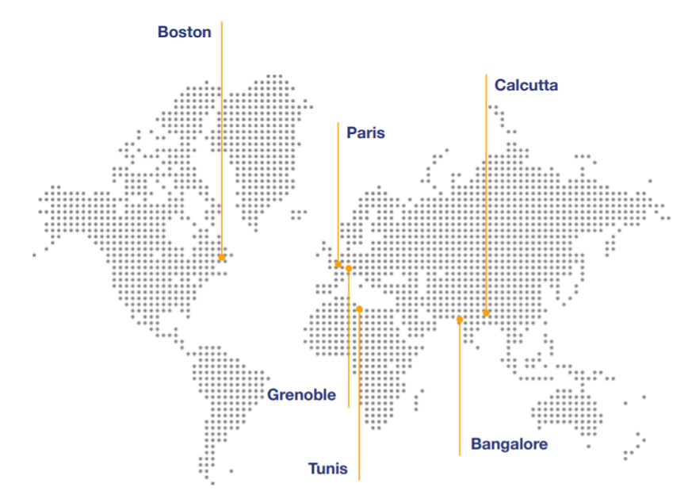
Figure 1 Edifixio across the world
Edifixio is therefore a small company but designs and implements solutions for key accounts of the French economy, in particular in the industrial manufacturing and luxury sectors.

1. Main activity




The company operates on major themes like:
COLLABORATIVE SOLUTIONS
PORTALS, INTRANETS, EXTRANETS AND WEBSITES
SOFTWARE DEVELOPMENT ON CLOUD PLATFORMS
CRM

2. History

3. Edifixio Business Partners
Across its history, Edifixio has forged partnerships with major actors of the digital world.

Salesforce

Salesforce is the baseline solution for CRM enterprise software. Edifixio is involved in the Salesforce ecosystem since 2010 and is a Salesforce Silver Partner Since 2015. Edifixio holds a great expertise in designing, developing, and delivering applications based on this platform.

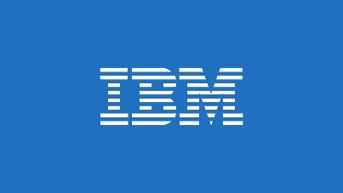
IBM
IBM Cloud offers cloud-based digital transition and AI services. As IBM Premier Business Partner since 2003, Edifixio is an expert at building solutions resting on the IBM Cloud.


AWS
AWS is the on-demand cloud platform created by Amazon. Being an AWS Premiere Consulting Partner since 2010, Edifixio has significant experience in delivering infrastructure built on top of AWS.

Azure

Azure is the cloud platform owned by Microsoft. Edifixio is expert with Microsoft Technologies since 2000 and holds several Microsoft titles like Silver Partner on Cloud Platform and Application Development and Gold Partner on Cloud Platform. This title demonstrates Edifixio’s ability to build solutions based on Azure Cloud.

MuleSoft
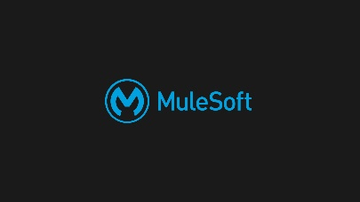
MuleSoft is a software brick to manage APIs lifecycles. Edifixio is positioned to become a MuleSoft partner in order to benefit from a synergy between Salesforce and MuleSoft to further improve performance.

II. ESIA Business Unit and Salesforce team

1. ESIA Business unit
My apprentice career path happens in the ESIA business unit. Its lines of business are integration and cloud. It is specialized in several activities like:
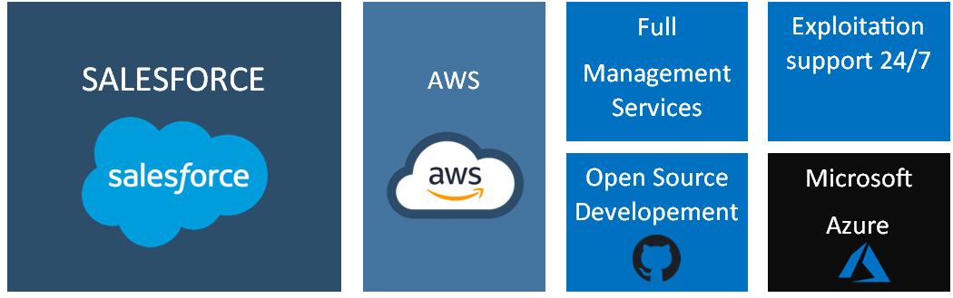
This business unit holds 280 collaborators.

2. Salesforce team
The Salesforce team, which depends on the ESIA business unit, develops solutions based on the Salesforce CRM platform. It includes business needs analysis, setup, business processes automation and custom software solutions development.

A growing team
The Salesforce team is the biggest and fastest growing team of Edifixio. Indeed, as Salesforce is adopted by more and more companies across the world, the demand for Salesforce consulting and Salesforce integration went through the ceiling, thus software consulting companies must adapt their abilities.

Diverse skillset
The team relies on two types of collaborators. First, Business Analysts, who are enterprise process specialists, use Salesforce “Low code” configuration interface to create all data and process needed for the Salesforce instance to be fully adapted to the company. However, several needs are so precise that they cannot be fulfilled using the “Low code” development model and require traditional software development. Therefore, the team includes software developers, entrusted to build these custom software solutions.



III. Salesforce Full Stack Developer
As an apprentice engineer, my position at Edifixio is Full Stack Developer in the Salesforce team. This position leads me to solve problems and meet business needs by designing and developing enterprise application on the Salesforce CRM platform.

1. Full Stack Developer

Design
As a developer part of my role is to understand business needs and specifications in order to design and scaffold strong software solutions. To achieve this goal, I leverage my software engineering skills, like SOLID principle or loose coupling to do my best to design performant and maintainable software. The first step I take is writing and debating an extensive specification. Then I decide which architecture and design patterns I will use by translating this specification into software engineering diagrams: UML class, use cases and sequences.
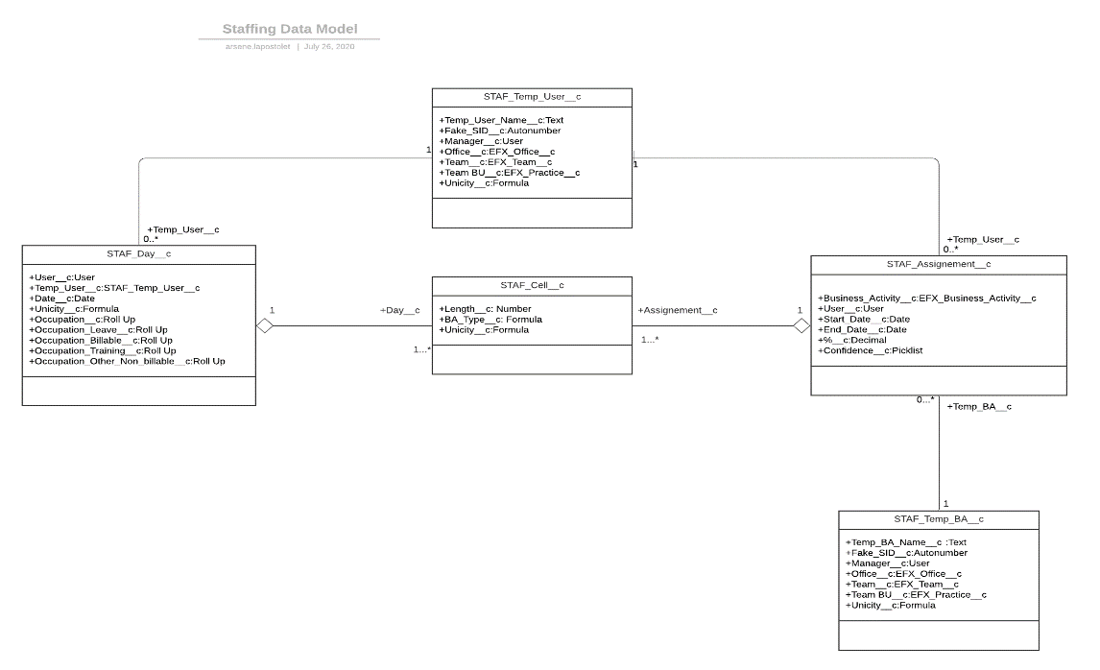
Figure 2 Example of class diagram
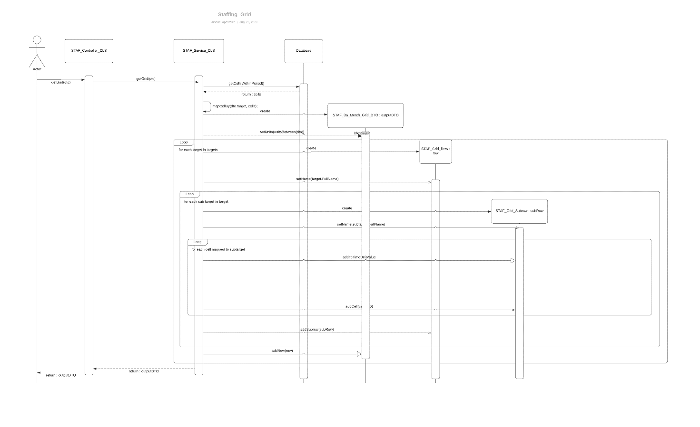
Figure 3 Example of sequence diagram

Develop
The central task of the developer job is writing code that implements engineering designs and thus fulfills the business requirements. Code must be tested in order to ensure that it produces an expected behavior.
My goal as a developer is to write clean, readable, maintainable code, in order to deliver applications as close to enterprise grade quality as possible. I improve the quality of my code everyday thanks to my school program, by reading online and by debating about code with my colleagues and friends.

Full Stack
As a full stack developer, like a craftsman, I operate in all steps of the software development process ; understand need, write specifications, design adapted software solutions, create engineering schematics, write the implementation code, working on the database schema, write the server side business logic and webservices code and write the user interface.

2. Develop on Salesforce

What is Salesforce?
Salesforce is a CRM oriented enterprise resource planning software. It is provided as an AWS hosted multi-tenant cloud platform.
Salesforce is aimed at easing digital transformation for companies, as it eases business processes automation. In addition, its cloud native nature frees the company from any infrastructure and scalability problematics. Salesforce is an object-oriented database with batteries included: all the CRM objects (Account, Lead, Campaign…) are already configured, and custom objects can be created by the integrator.
The platform can be accessed through web & mobile GUIs. To automate business process the integrator can use “Low Code” tools to create the data model, business process, reporting and analytics by configuration through the GUI. But for more sophisticated business needs, a SDK is provided to develop fully custom apps on the platform.
Salesforce is very versatile and provides software bricks specialized for certain types of organizations:
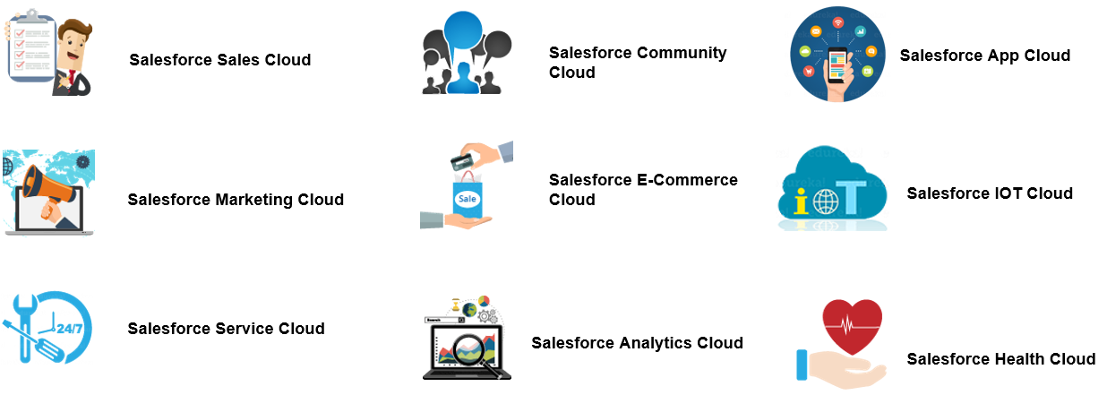
Salesforce skills are in demand as more and more companies adopt it to ease their way into the digital transition.
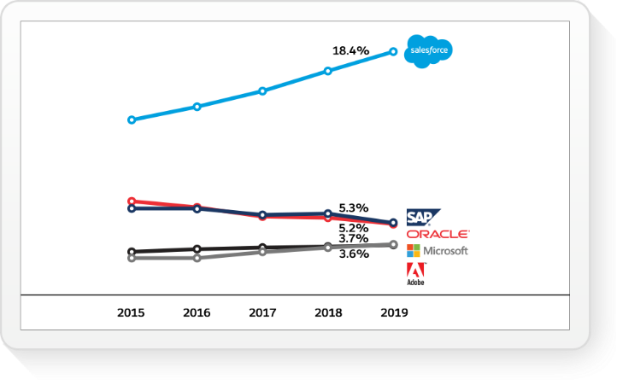
Figure 4 Salesforce's CRM Market Share

Salesforce Applications Development
Salesforce provides a Software Development Kit containing several technologies:

Database
Salesforce features an object-oriented database to store all the data required to model the organization’s business process. Developers can query data from Salesforce using SOQL and SOSL.
SOQL (stands for Salesforce Object Query Language) is a SQL-like structured query language the fetch data from Salesforce’s database. Joins are expressed to an objects-oriented syntax with lookup fields.
User__r is a lookup field on the user object wihch uses User__c as foreign key.
SELECT Id,User__r.Name,User__c, FROM EFX_User_Additionnal_Info WHERE Country__c = 'France'

SOSL (stands for Salesforce Object Search Language) is a structured language to search values in record text, à la Apache Lucene. I never had to leverage this tool as it is situational, yet very powerful.
FIND 'SFDC' IN ALL FIELDS
RETURNING Account(Name), Contact(FirstName,LastName)

Backend
APEX is a strongly typed, imperative and object-oriented language created by Salesforce to write backend code. Its syntax and overall features are very close to Java or C#:
APEX provides Data Manipulation instructions to interact with Salesforce database and the ability to use language integrated SOQL queries whose result are mapped to APEX objects.
public class Car extends WheeledVehicle implement Vehicle {
public Engine engine {get;set;}
public List<Wheel> wheels {get;set;}

public Car (Engine engine){
this.engine = engine;
this.wheels = new List<Wheels>();
for(Integer i = 0;i < 4;++i){
this.wheels.add(new Wheel());
}
}

public override move(){
...
}
}

Salesforce provides a lot of APEX APIs needed to implement the backend of any business needs: triggers on the database, web services, unit test and background batch jobs.
Account a = new Account(Name='Acme2');
insert a;
Account myAcct = [SELECT Id, Name, BillingCity FROM Account WHERE Id = :a.Id];
myAcct.BillingCity = 'San Francisco';
update myAcct;

Frontend
Salesforce can be used through two different frontends: Salesforce Classic, which is a legacy UI, with outdated UI & UX, based on the old Visualforce Framework. Visualforce is a JSP-like templating framework; it is page oriented and with server-bound rendering, AJAX is possible but very cumbersome.
The prevailing UI is Lightning Experience (LEX), which implements the very up to modern standards Salesforce Lightning Design System (SLDS). LEX is component oriented and offers an interactive and rich user experience. This UI is rendered on the client side; it relies on server calls only for backend logic by using webservices. Lightning experience relies on the Lightning Components.
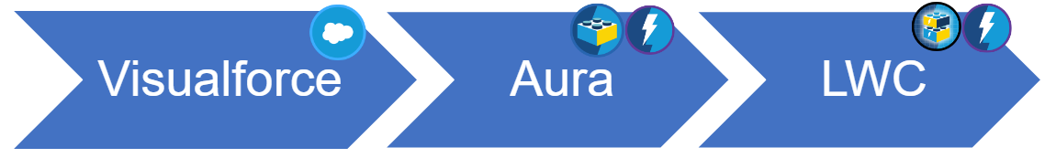
Figure 5 Salesforce UI Evolution
To develop Lightning Components, Salesforce offers two different frameworks.
The first framework, Aura, is deprecated but still used in many apps. It is not web native and not web standard, using a custom proprietary Javascript compiler and DOM renderer. Thus, it offers poor performance for large apps.
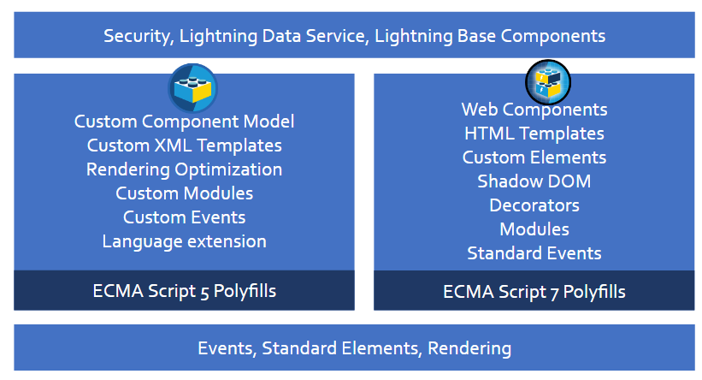
Then last year, Salesforce released a brand-new frontend framework: Lightning Web Components (LWC). LWC leverages standard web technologies like web components, shadow DOM and standard HTML templates. Thus, LWC is lightning fast even for large apps and features a very modern programming model.
Figure 6 LWC vs Aura

Lightning components developed with different frameworks can coexist and interoperate in an app.

Work Organization

Process
Since I am working alone on my project for now, my business process is quite simple. At the beginning of the project, I work with the Project Manager (PM) to break down the tasks into a list of tickets. Then, for each ticket, I go through several steps. First, I mark the ticket, in progress, and work to achieve it in the development environment (a Salesforce Alpha Sandbox) by writing backend and/or frontend code, and unit tests for backend logic. Sometimes when the feature includes complex UI & UX, I take input from a designer who creates UI mockups for me to implement. When done, I mark the tickets as “In Quality Analysis” (QA), for the PM to tinker with the feature in the dev environment. Based on his experience with the feature, he validates it or puts it back as “In Progress” for me to fix it. If it is validated, I deploy it on the production environment (Edifixio’s Salesforce Org) to make it available for the average user.

Project Management Tools
To manage the tickets, we use JIRA developed by Atlassian, which is a project management software that provides a Kanban-like UI. JIRA offers a huge set of features to create detailed tickets, and then categorize, and manipulate them. For real time chat and video conferencing we mainly use Google Hangouts but also Microsoft Teams.
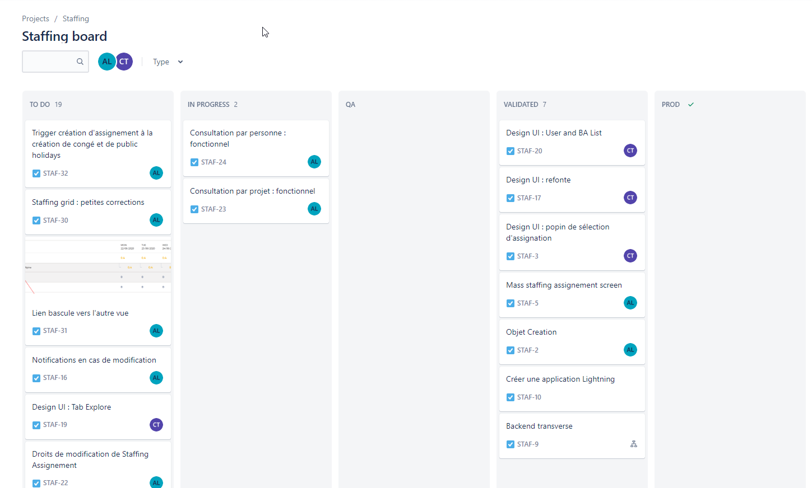
Figure 7 Project Kanban Board

Salesforce Full Stack Developer Toolbox
Since Salesforce is a cloud platform, we, as developers, use specific tools to write code for the platform.

JetBrains IntelliJ IDEA
IntelliJ is an industry leading integrated development environment for Java & JVM languages. It provides smart code completion and complex refactors. IntelliJ is also very versatile thank to its rich plugins system and its already sleek UI is completely customizable. What I particularly appreciate in the IDE are the well design keyboard workflows, allowing to perform complex action without touching the mouse, and thus save a lot of time.

Illuminated Cloud
In combination with IntelliJ, I use Illuminated Cloud, a plugin that empowers JetBrains’ IDE with all the tools I need to develop on Salesforce. It provides APEX language support, Aura an LWC integration for Javascript. On top of that, the plugin features an UI leveraging Salesforce Tooling API to run, create, delete, push, and retrieve code from a Salesforce Org. Illuminated Cloud also features a view to read the Org’s logs, a SOQL console and an anonymous APEX interpreter to test code snippets. An APEX debugger is available, but it is not really usable.

Salesforce Workbench
To perform some actions, like destructive changes to production Orgs or to do data import/export from/to CSV, Salesforce provides a web application called Workbench. It is a very basic app that allows to perform mass CRUD operations.

III. Achievements

Timesheet Report Project
During my internship at Edifixio (before my apprenticeship), I developed an application, Tock, which automates the process of keeping track of the employees worked hours count. Each week, the employees must fill in their tock timesheet: they submit for each day which fraction of their working time was allocated to each project. They may also declare overtimes and on calls, which must be validated by their manager in a dedicated UI. This process generates a high amount of data, like the cost of the project, the performance of the teams and the resources staffing rates.
Tock features a time-based grid view with week granularity. Several controls are available to navigate the grid through time. The rows model the project (called Busines activities or Tock Codes). The columns model a tock day, which binds a date and a user. The cells content models the time spent each day on each project. Each day must have a total of 1, which corresponds to 100% of the day’s working. Special non-editable rows and cells are inserted for holidays and leaves. The app also keeps track of overtimes and on calls.
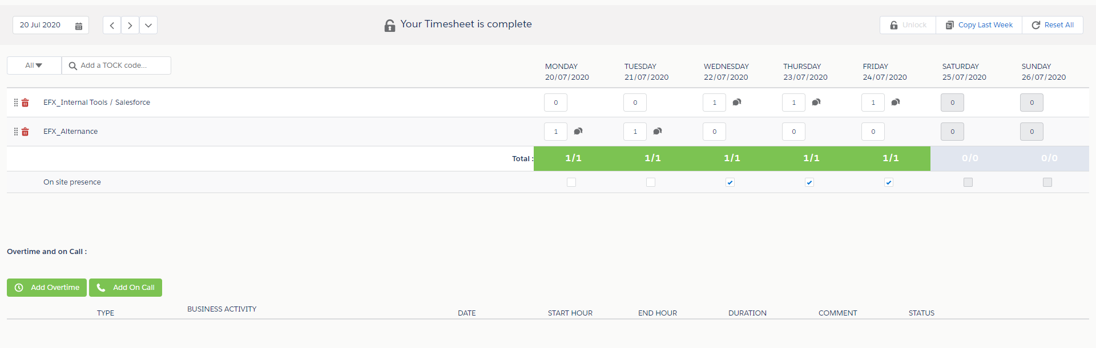
Figure 8 Tock Application
Timesheet Report is a reporting app which relies on the data generated by Tock to produce reports used by the HR & Finance team through an intuitive and responsive web interface. Timesheet report is a form with a lot of parameters to target precise data. Multiple form types are supported (Time spent, staffing, overtimes, payroll), with a precise business use for each of them as well as several display modes for each type (detail/total, day/week).
The report creation UI features intuitive and powerful custom controls to enable the user to easily build the report that fits his needs. This report parameters can also be saved for future usage.

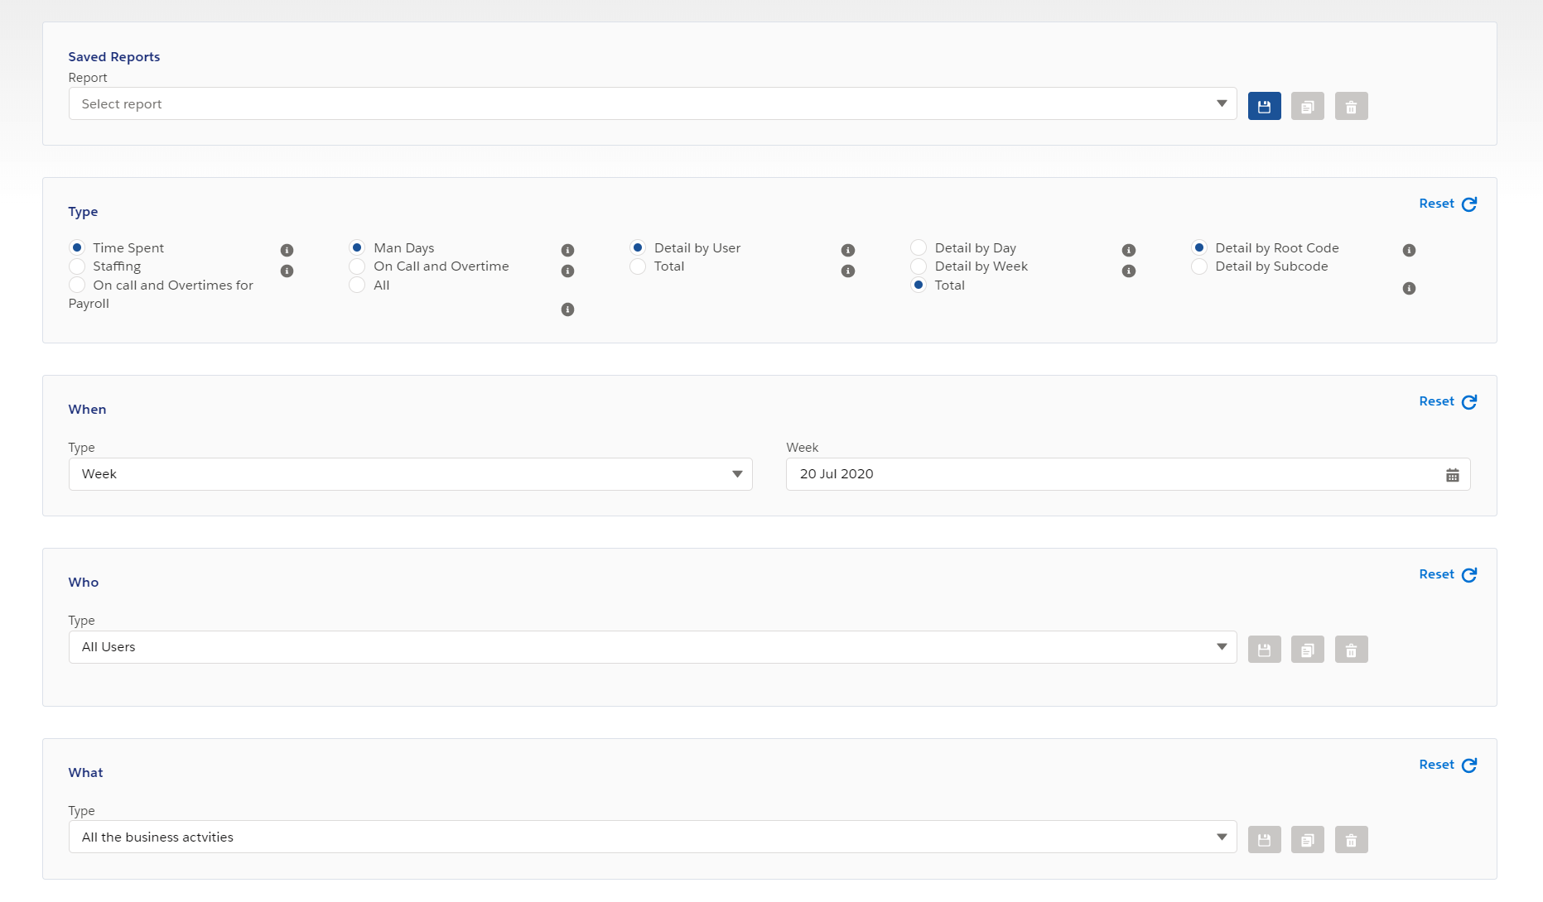
Figure 9 Timesheet Report Application

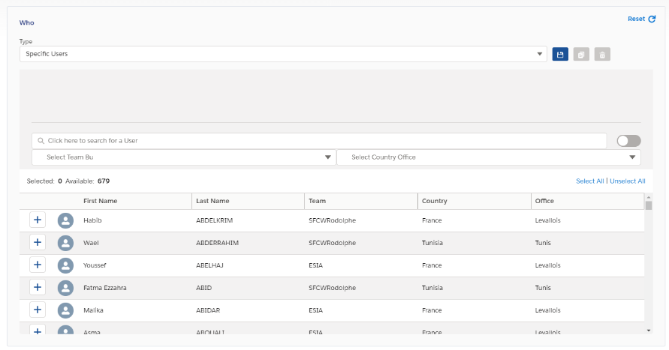
Figure 10 User List Control
This control allows the user to target a fine-tuned list of users with their reports, featuring geographic filtering and fuzzy search. The lists can be saved for future usage.

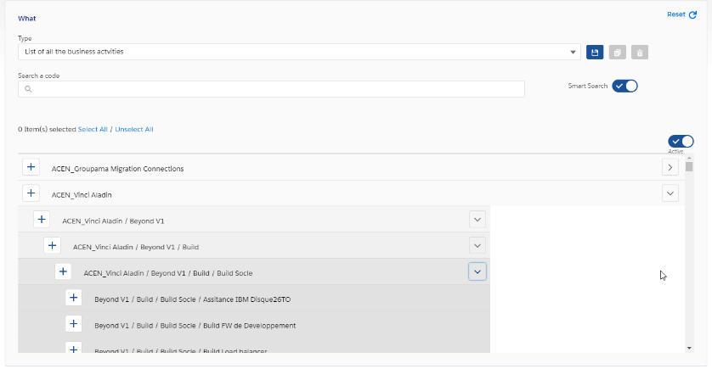
This control as the same goal but is aimed at selecting projects in their complex hierarchy. It also features fuzzy search and list save for future usage.
Figure 11 Business Activity List Control

When the report parameters are filled, the user can either Launch the report to have the 200 first lines of it displayed on the UI. To see the full data, the user must download the report in CSV format. Report relying on many records (more than 25000) cannot be processed in real time and hence cannot be downloaded. They are created by background batch processing and sent by email.

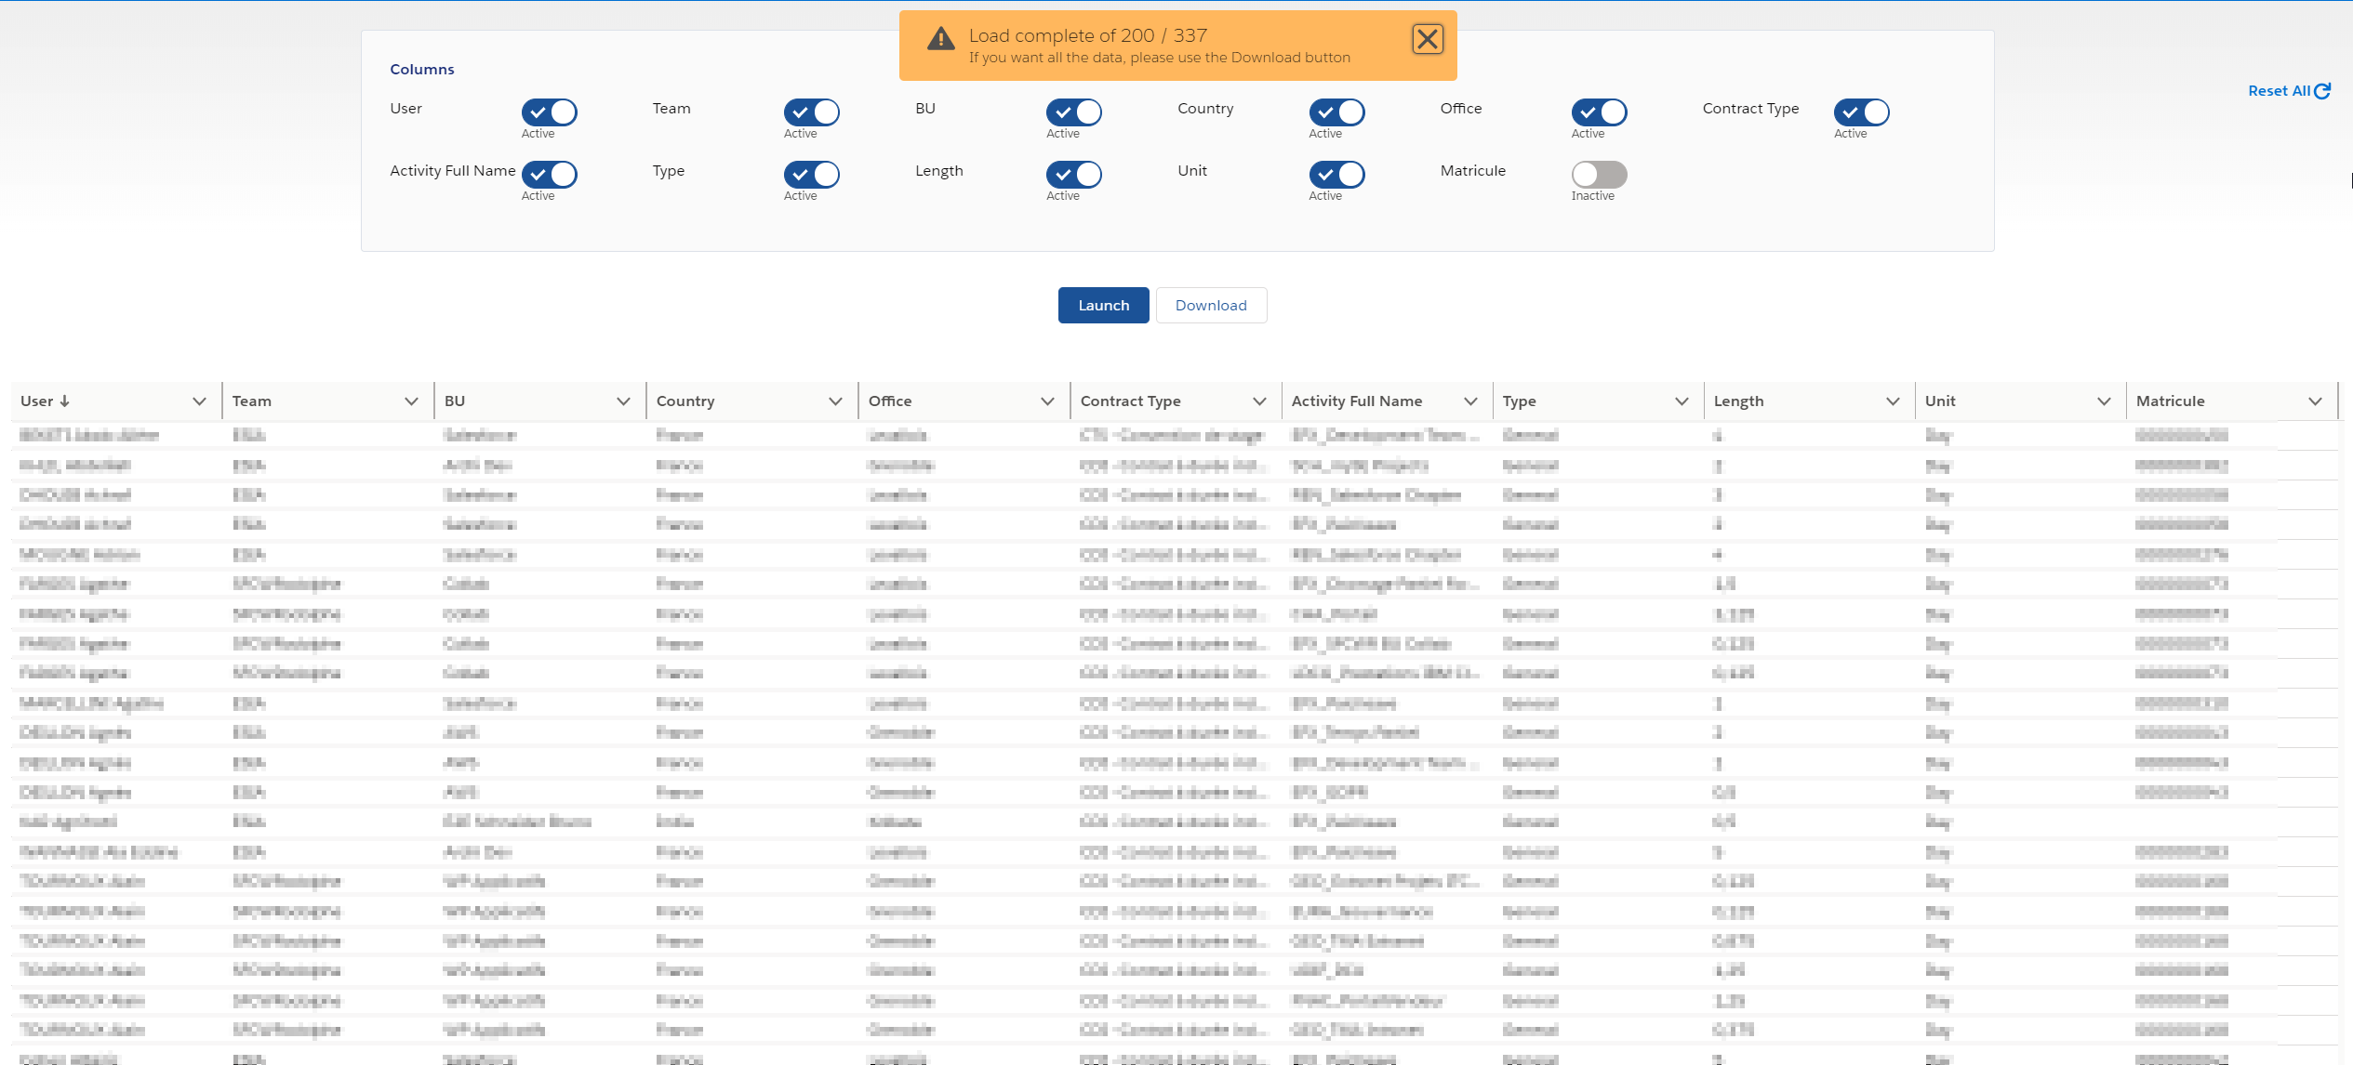
Figure 12 Timesheet Report Application

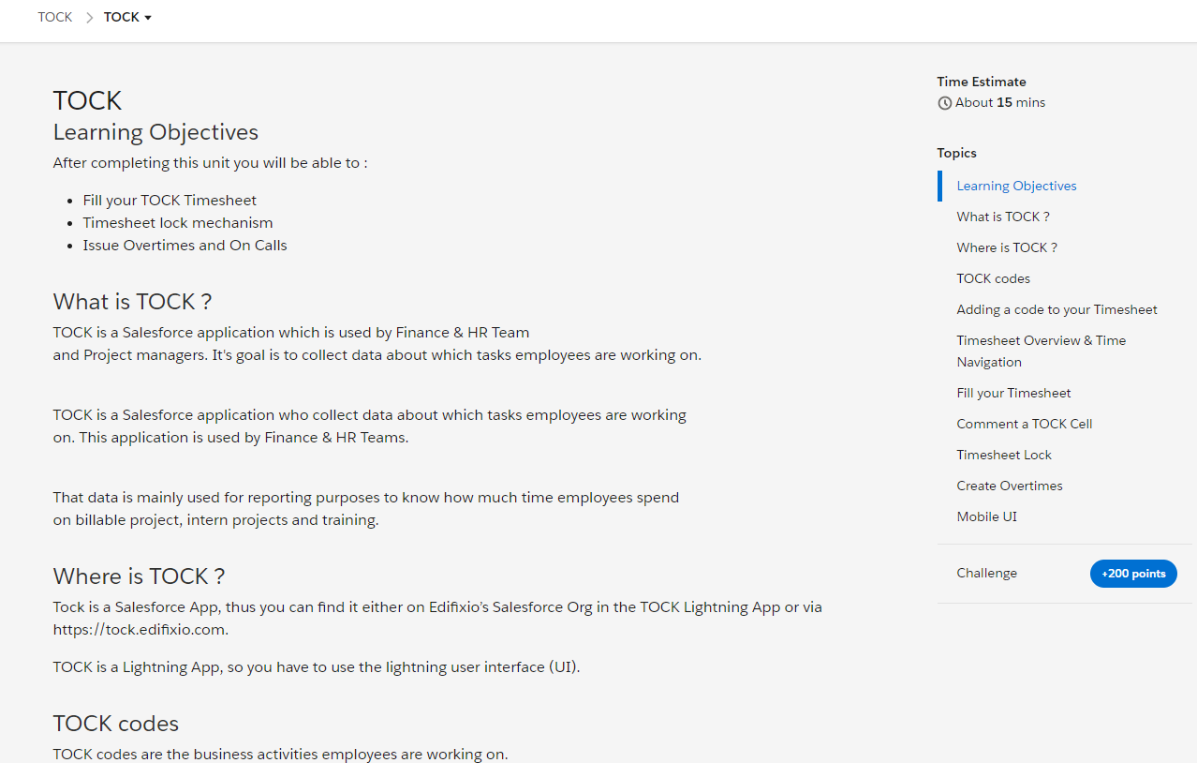
After completing both Tock and Timesheet Report projects, I was bound to write an extensive user documentation since those applications are meant to be used by a lot of Edifixio’s employees. To fulfill this assignment, I wrote a module for Edifixio’s Trailhead instance. Trailhead is a gamified e-learning platform by Salesforce to train at Salesforce platform. It was an interesting and challenging experience, because it forced me, more than usual, to put myself in the user’s shoes to try and grasp his appreciation of any piece of documentation and the application user experience.
Figure 13 Tock Trailhead module

TRH Project
Once most of the work on Timesheet report was done, I was provisioned on a new project: TRH. TRH is an Edifixio internal application which manages employees. The employees can issue leave requests and the HR admins can approve these requests.
The legacy version of this app was a Java JSF application developed and hosted here at Edifixio. It was very old and filled with discrepancies. Hence, The TRH consists to redevelop TRH as a Salesforce app on Edifixio’s Org to intimately integrate with all the others automated business process of the company that happen on Salesforce. Another goal is to offer a much more modern and user-friendly user interface.
This project is directed by Benjamin Trotin, a colleague and friend of mine who happens to be another EFREI apprentice working with me on Edifixio’s Salesforce Internal Tools.
On this project, my role was to develop secondary software components to ease Benjamin’s workload and allow him to focus on the complicated business requirements and the main UI, which he was working on for a long time. For instance, I enhanced several components to make them mobile compliant and created PDF and CSV reporting UIs.
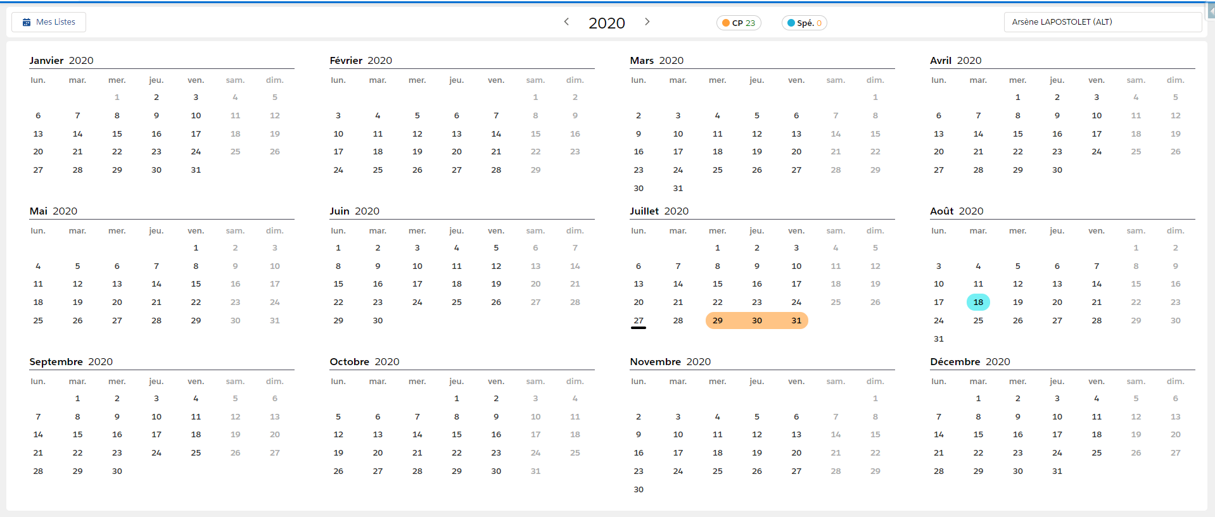
Figure 14 TRH Main UI

Staffing Project
My last assignment of the year was a new application: Staffing. The goal of this app is to allow team managers to establish the planned workload of their resources in the future in a sleek and streamlined UI and ultimately to perform advanced reporting on the provided data. The user can create assignments, which bind a resource to a project during a period and at a certain occupancy rate. It allows to calculate the man days by users and by project and present them in a powerful and editable grid UI provided with diverse time granularity.
Assignments are modeled by the assigned user, the project he is assigned to, the assignment start date, its end date, the resource’s occupation rate, the man days it represents, and the confidence on this projection. Among the dates, the occupation rate and man days, three fields are filled by the user, the fourth is automatically calculated, taking in account weekends and holidays for the resource’s office.

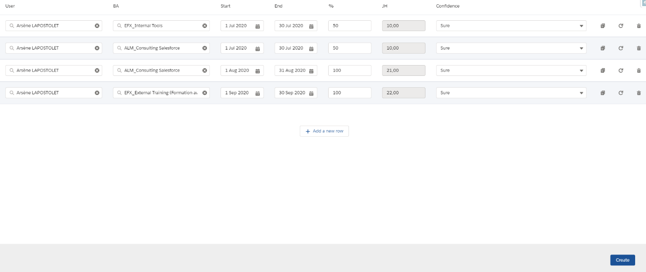
Figure 15 Staffing Mass Creation

The mass creation tool features conflicts detection and resolution with different strategies when a resource’s assignments overlap.
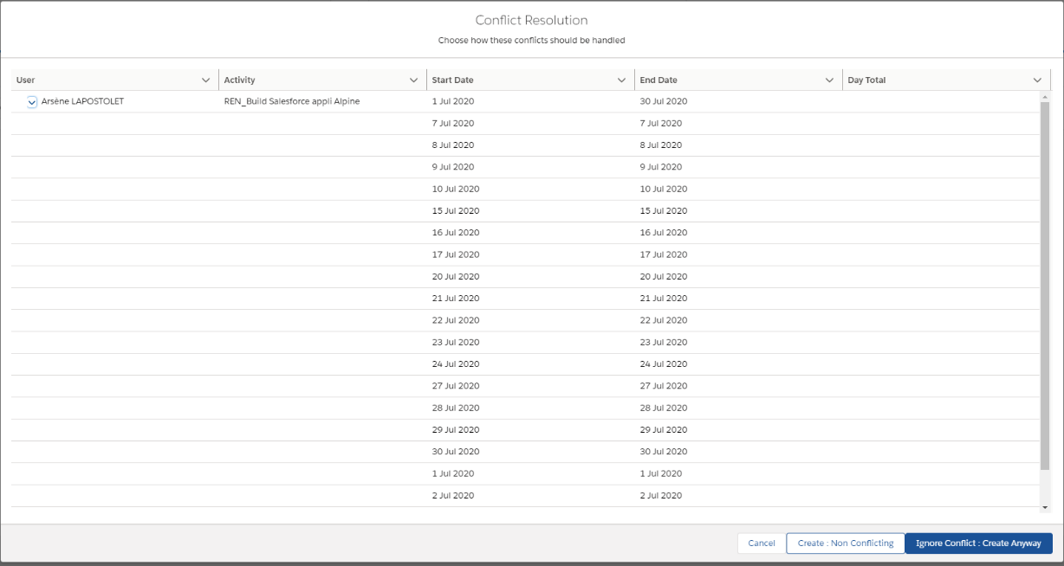
Figure 16 Staffing Conflict Resolution
The data created through the mass creation interface are then displayed in powerful grid view, featuring user by project and project by user layouts, multiple time granularities, and time navigation.
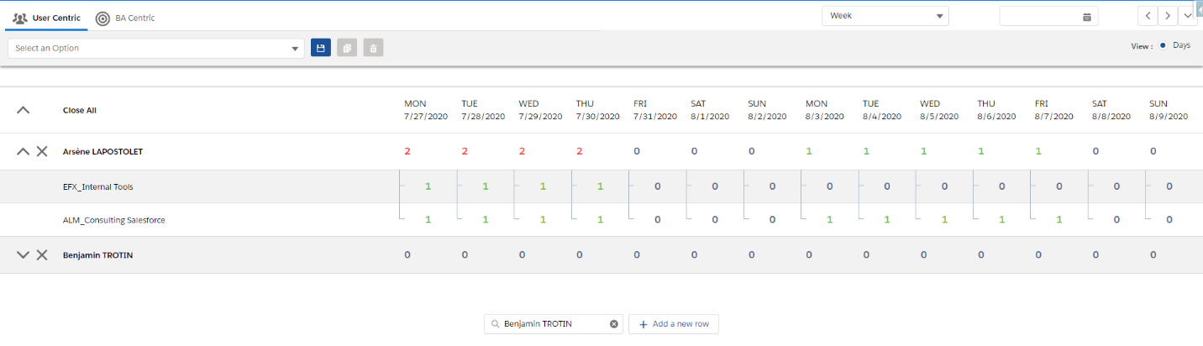
Figure 17 Staffing Grid

IV. Achievements statement

Challenges encountered
The most complicated challenge I had to overcome was during the development of Timesheet Report, when I encountered the Salesforce Governor Limits. Indeed, as Salesforce is a cloud hosted PaaS software, some limitations on things like APEX CPU time, data manipulation language (DML) calls count, SOQL queries count, SOQL queries result size are enforced in synchronous APEX. In the case of Timesheet Report, such limitations were a concern since reports may query a huge amount of records in some case (usually when creating reports on a large time span). Pagination was not possible since users needed complete CSV exports. We partially overcame this issue by processing big reports on background APEX batch jobs which are allowed much more generous limitations and sending the result of the batch via email. But some reports that contained a lot of lines still failed, because the amount of data overflowed APEX data types when exporting to CSV.
I also faced a minor challenge on the Staffing project by writing the algorithm generating the grid UI and the UI logic since it leverages a lot of data with complex structure and I wanted to create something as flexible and extendable as possible.

Acquired abilities
Thanks to my coursework and my work as an apprentice, I acquired several abilities and improved others.
First, I increased the overall quality of the code I write, by writing short methods with relevant names, and appropriate code documentation. Among other things, I learnt how to use JSDoc to improve code linting in Javascript.
Then, I upgraded my mastery of Javascript, the DOM and Shadow DOM by developing Lightning Web Components, and that allowed me to better understand LWC rendering. I also discovered advanced CSS techniques to develop very custom components.
Furthermore, I experienced of to apply my software engineering knowledge to Salesforce backend development. It allowed me to achieve a good quality of code, with SOLID principles in mind.
Finally, acquired a lot of valuable knowledge and abilities on the Salesforce ecosystem. For instance, I learnt how to write performant APEX Data Manipulation Language (DML), discovered more Salesforce APIs, how to import/export data and how to leverage Low Code features offered by salesforce to implement business needs.

Evolution perspectives
As of today, one of my next big objectives is to pass the Salesforce Developer I Certification. It is yet a tedious task since I am always busy with projects.
Soon, once I pass this certification, I could get new kind of assignments and work not only on developing internals tools but also to work on real world project for actual Edifixio’s clients.
In the distant future I will then be bound to pass the Salesforce Developer II Certification and acquire new abilities, like Salesforce application architecture, life cycle and monitoring.

Conclusion
Throughout this year of being a Salesforce full stack developer at Edifixio, I was assigned to three different projects which were enriching and allowed me to strengthen my abilities at Salesforce application development as well as my overall understanding of the Salesforce platform. I did the best I could to fulfill these assignments and I am proud of the results. I produced applications that are welcomed by their end users and with a code of appreciable quality. I still have a lot to learn, and in fact, I think that one never stops to learn, and I look forward to endlessly learn about full stack development and software engineering.
Working at Edifixio was also an excellent experience on the human point of view. I feel comfortable and even happy to come at work, and share time with my colleagues.
I am eager to start next year school modules as well as future assignments at Edifixio. Feeling empowered by my experience and my training, I am keen to tackle the challenges that lie ahead.

Table of figures
Figure 1 Edifixio across the world 7
Figure 2 Example of class diagram 12
Figure 3 Example of sequence diagram 13
Figure 4 Salesforce's CRM Market Share 14
Figure 5 Salesforce UI Evolution 17
Figure 6 LWC vs Aura 17
Figure 7 Project Kanban Board 18
Figure 8 Tock Application 20
Figure 9 Timesheet Report Application 21
Figure 10 User List Control 21
Figure 11 Business Activity List Control 21
Figure 12 Timesheet Report Application 22
Figure 13 Tock Trailhead module 22
Figure 14 TRH Main UI 23
Figure 15 Staffing Mass Creation 24
Figure 16 Staffing Conflict Resolution 25
Figure 17 Staffing Grid 25

